Laboratory Exercise No. 3
Graphical Analysis of Linear Programming Problems Using Graphical Calculator
1. Objective:
The activity aims to analyze LP problems using graphical calculator.

2. Intended Learning Outcomes (ILOs):
The students shall be able to:
  - Solve LP using graphical calculator.

3. Discussion :
A linear programming problem involving only two decision variables can be solved using a graphical solution procedure. In a linear programming problem, we need to identify the solution points that satisfy all the constraints simultaneously. To find these solution points, we can draw all constraints one one graph and observe the region containing the points that do in fact satisfy all the constraints simultaneously. The steps of the graphical solution procedure for a maximization problem are summarized here:
- Prepare a graph of the feasible solution for each of the constraints.
- Determine the feasible region by identifying the solutions that satisfy all the constraints simultaneously.
- Draw an objective function line showing the values of the decision variables that yield a specified value of the objective function.
- Any feasible solution on the objective function line with the largest value is an optimal solution.

The optimal solution to a linear program can be found at an extreme point of the feasible region. Actually, the graphical solution procedure is nothing more than a convenient way of identifying an optimal extreme point for two-variable problem.

4. Resources:
Graphing Calculator (

5. Procedure:
- a. Identify the feasible region for the following set of constraints:
0.5 A + 0.25 B ≥30
1A + 5 B ≥250
0.25A + 0.50 B ≤ 50
A,B ≥ 0
Use Figure 1.a for your answer.
b. Identify the extreme points. Show your answers in Table 1.b.
- a. Identify the feasible region for the following set of constraints:
7/10 S + 1D ≤ 630
½ S + 5/6 D ≤ 600
1S + 2/3 D ≤ 708
1/10 S + 1/4D ≤ 135
S,D ≥ 0

Use Figure 2.a for your answer.
b. Identify the extreme points. Show your answers in Table 2.b.
c. For the objective
Max 10S + 9D
Determine the optimal point by substituting the extreme points in the objective function. Show the optimal line. Use Figure 2.c
- a. Identify the feasible region for the following set of constraints:
1A + 2B ≤ 6
5A + 3B ≤ 15
A,B ≥ 0

Use Figure 3.a for your answer.
b. Identify the extreme points. Show your answers in Table 3.b.
c. For the objective
Max 2A + 3B
Determine the optimal point by substituting the extreme points in the objective function. Show the optimal line. Use Figure 3.c

- RMC, Inc. is a small firm that produces
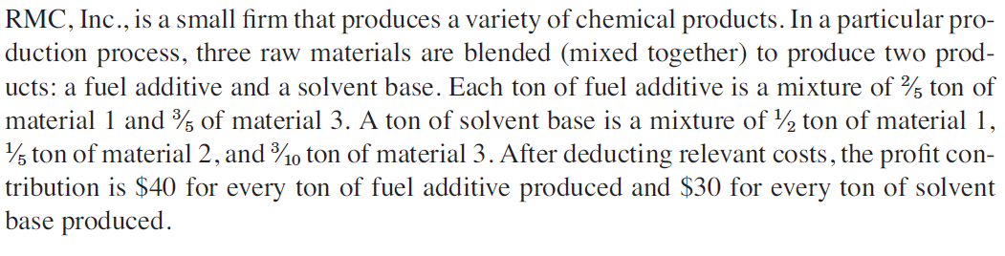
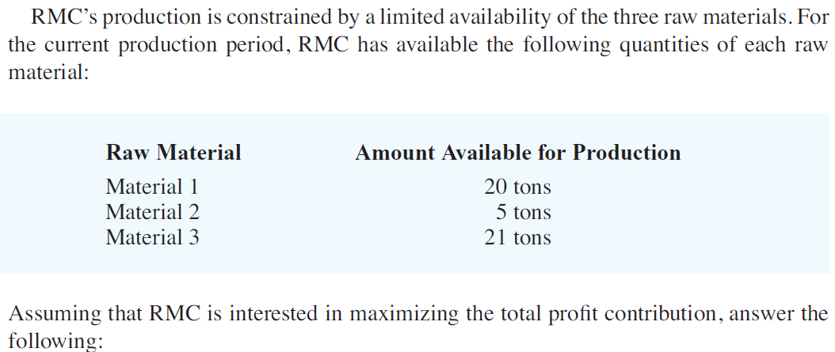

a. Identify the set of constraints of Procedure 4 LP problem. Use Table 4.a for your answers.
b. Identify the feasible region of the constraints obtained in Procedure 4.a.
Use Figure 4.b for your answer.
c. Identify the extreme points. Show your answers in Table 4.c.
d. For the objective function of Procedure 4 LP problem. Determine the optimal point by substituting the extreme points in the objective function. Show the optimal line. Use Figure 4.d

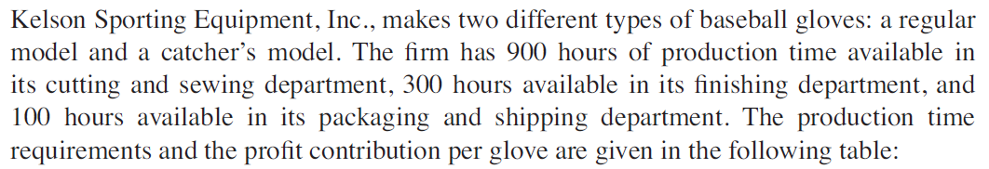
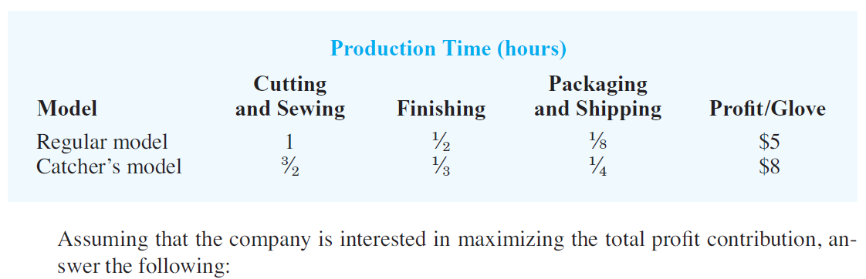
a. Identify the set of constraints of Procedure 5 LP problem. Use Table 5.a for your answers.
b. Identify the feasible region of the constraints obtained in Procedure 5.a.
Use Figure 5.b for your answer.
c. Identify the extreme points. Show your answers in Table 5.c.
d. For the objective function of Procedure 4 LP problem. Determine the optimal point by substituting the extreme points in the objective function. Show the optimal line. Use Figure 5.d

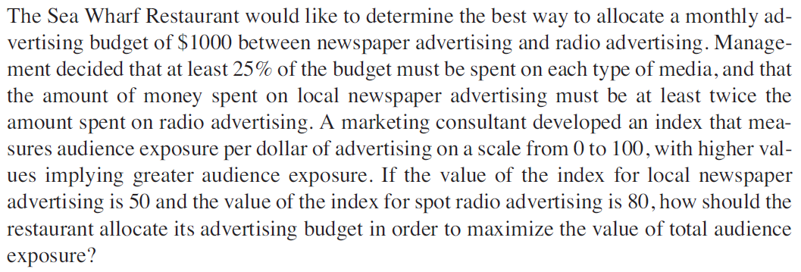
a. Identify the set of constraints of Procedure 6 LP problem. Use Table 6.a for your answers.
b. Identify the feasible region of the constraints obtained in Procedure 6.a.
Use Figure 6.b for your answer.
c. Identify the extreme points. Show your answers in Table 6.c.
d. For the objective function of Procedure 6 LP problem. Determine the optimal point by substituting the extreme points in the objective function. Show the optimal line. Use Figure 6.d

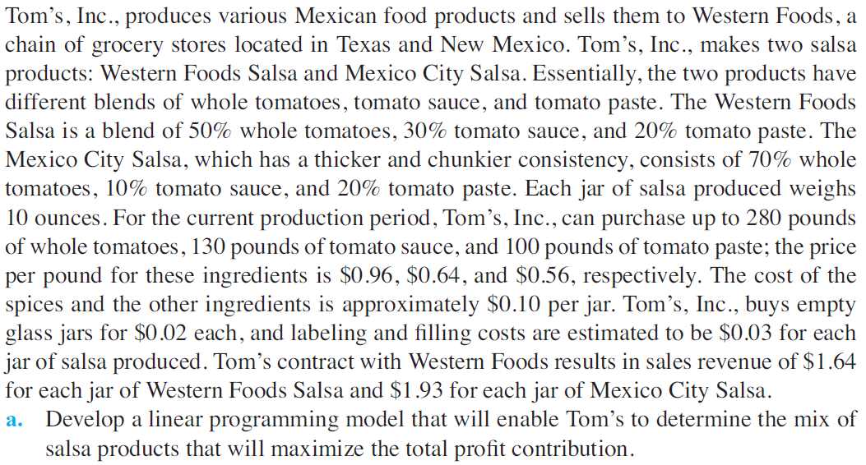
a. Identify the set of constraints of Procedure 7 LP problem. Use Table 7.a for your answers.
b. Identify the feasible region of the constraints obtained in Procedure 7.a.
Use Figure 7.b for your answer.
c. Identify the extreme points. Show your answers in Table 7.c.
d. For the objective function of Procedure 7 LP problem. Determine the optimal point by substituting the extreme points in the objective function. Show the optimal line. Use Figure 7.d

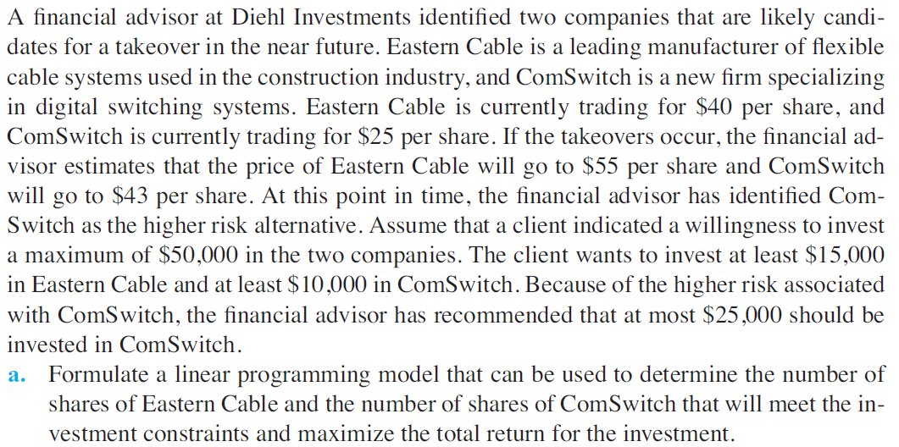
a. Identify the set of constraints of Procedure 8 LP problem. Use Table 8.a for your answers.
b. Identify the feasible region of the constraints obtained in Procedure 8.a.
Use Figure 8.b for your answer.
c. Identify the extreme points. Show your answers in Table 8.c.
d. For the objective function of Procedure 8 LP problem. Determine the optimal point by substituting the extreme points in the objective function. Show the optimal line. Use Figure 8.d

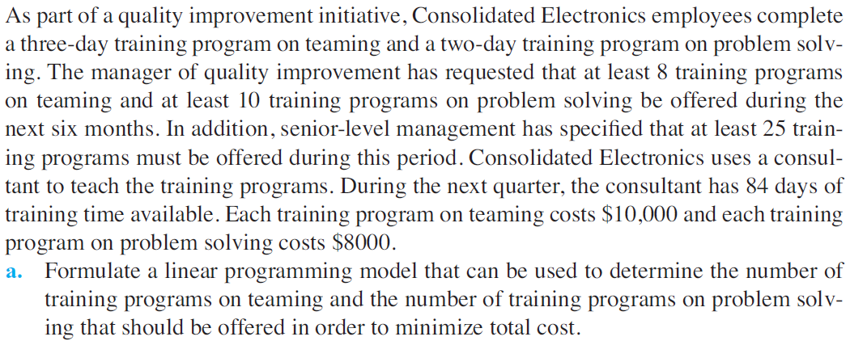
a. Identify the set of constraints of Procedure 9 LP problem. Use Table 9.a for your answers.
b. Identify the feasible region of the constraints obtained in Procedure 9.a.
Use Figure 9.b for your answer.
c. Identify the extreme points. Show your answers in Table 9.c.
d. For the objective function of Procedure 9 LP problem. Determine the optimal point by substituting the extreme points in the objective function. Show the optimal line. Use Figure 9.d

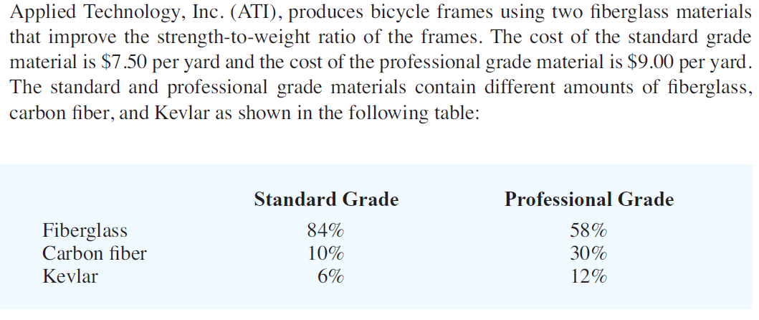
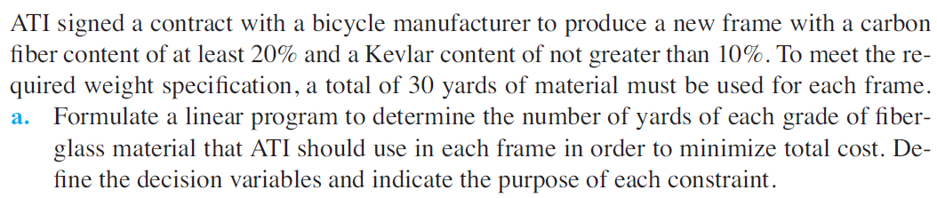

a. Identify the set of constraints of Procedure 10 LP problem. Use Table 10.a for your answers.
b. Identify the feasible region of the constraints obtained in Procedure 10.a.
Use Figure 10.b for your answer.
c. Identify the extreme points. Show your answers in Table 10.c.
d. For the objective function of Procedure 10 LP problem. Determine the optimal point by substituting the extreme points in the objective function. Show the optimal line. Use Figure 10.d

Course: | Laboratory Exercise No.:
Group No.: | Section:
Group Members: | Date Performed:
 | Date Submitted:
 | Instructor:
6. Data and Results:
- Procedure 1
Figure 1.a Feasible Region for Procedure 1 Set of Constraints

Table 1.b Extreme Points of the feasible region in Figure 1.a

- Procedure 2
Figure 2.a Feasible Region for Procedure 2 Set of Constraints

Table 2.b Extreme Points of the feasible region in Figure 2.a

Figure 2.c Feasible Region with Optimal Line for Procedure 2 Set of Constraints

- Procedure 3
Figure 3.a Feasible Region for Procedure 2 Set of Constraints

Table 3.b Extreme Points of the feasible region in Figure 3.a

Figure 3.c Feasible Region with Optimal Line for Procedure 3 Set of Constraints

- Procedure 4
Table 4.a Set of Constraints of Procedure 4 LP Problem
Figure 4.b Feasible Region for Procedure 4.a Set of Constraints
Table 4.c Extreme Points of the feasible region in Figure 4.a
Figure 4.d Feasible Region with Optimal Line for Procedure 4.a Set of Constraints

- Procedure 5
Table 5.a Set of Constraints of Procedure 4 LP Problem
Figure 5.b Feasible Region for Procedure 4.a Set of Constraints
Table 5.c Extreme Points of the feasible region in Figure 5.a
Figure 5.d Feasible Region with Optimal Line for Procedure 5.a Set of Constraints

- Procedure 6
Table 6.a Set of Constraints of Procedure 6 LP Problem
Figure 6.b Feasible Region for Procedure 6.a Set of Constraints
Table 6.c Extreme Points of the feasible region in Figure 6.a
Figure 6.d Feasible Region with Optimal Line for Procedure 6.a Set of Constraints

- Procedure 7
Table 7.a Set of Constraints of Procedure 7 LP Problem
Figure 7.b Feasible Region for Procedure 7.a Set of Constraints
Table 7.c Extreme Points of the feasible region in Figure 7.a
Figure 7.d Feasible Region with Optimal Line for Procedure 7.a Set of Constraints

- Procedure 8
Table 8.a Set of Constraints of Procedure 8 LP Problem
Figure 8.b Feasible Region for Procedure 8.a Set of Constraints
Table 8.c Extreme Points of the feasible region in Figure 8.a
Figure 8.d Feasible Region with Optimal Line for Procedure 8.a Set of Constraints
- Procedure 9
Table 9.a Set of Constraints of Procedure 4 LP Problem
Figure 9.b Feasible Region for Procedure 9.a Set of Constraints
Table 9.c Extreme Points of the feasible region in Figure 9.a
Figure 9.d Feasible Region with Optimal Line for Procedure 9.a Set of Constraints

- Procedure 10
Table 10.a Set of Constraints of Procedure 4 LP Problem
Figure 10.b Feasible Region for Procedure 10.a Set of Constraints
Table 10.c Extreme Points of the feasible region in Figure 10.a
Figure 10.d Feasible Region with Optimal Line for Procedure 10.a Set of Constraints

7. Conclusion:
8. Assessment (Rubric for Laboratory Performance):
<Provide a one-page rubric here … delete this message after doing so.>

